1. Editing files directly on colab: (Note you must be aware of other methods to manually upload/download files).
   1. Any file on colab can be edited by first seeing the contents of the file by using **%cat <fileName>** in a new cell. Filename with the right path of course.
   2. Then paste the output content in a ‘new cell’. Then on top use the command **%%writefile <fileName>** to see the file saved.Filename with the right path of course.See screenshot below:

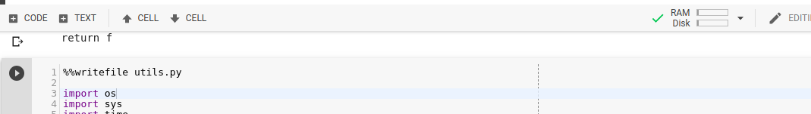

* 1. Do remember to run the file to ensure that the changes that you made reflects in your colab’s ipython environment by using %run magic function as follows **%run <yourFileName>** . In absence of this, though you make changes to the file it will not reflect on your colab environment. (i.e. say you added a new function, you will not be able to call it within colab).

2. Ensure you’re in the right folder structure when running your Colab cells. Several parts of the code sometimes depend on the right base directory.

3. Add **%%capture** as a top line on the cell to suppress log messages on Colab output. This would be necessary sometimes because log messages might hang the colab session. And this could act as a convenient switch.

4. Ensure you press “Refresh” each time you wish to see the files under the current Colab file structure:

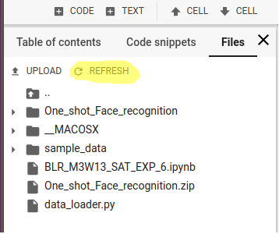

4. The folder structure need not be preserved when loading the images into the **IMFDB_train_sorted.txt** and **IMFDB_test_sorted.txt files.** For example, though the celeb Aamair Khan’s photo’s are shared in the following format format: **AamairKhan/3Idiots/images/Amir_103.jpg** , a simple **AamairKhan/Amir_103.jpg** is also sufficient from the perspective of how the code handles the structure. The folder name “**AamairKhan”** is however critical as that determines the name of the label.

5. You can use the following script (run it on colab by substituting <your folder name> with the name of the folder in colab where you have your images; i.e. mostly your own name ) to generate the file list that you have to add to IMFDB_train_sorted.txt and IMFDB_test_sorted.txt files:

**for residingFolder,_,allFiles in os.walk("./data/IMFDB_final/<your folder name>"):**

**for files in allFiles:**

**print(residingFolder.split('/')[-1]+"/"+files)**